|  |
| --- |
| **VISVESVARAYA TECHNOLOGICAL UNIVERSITY**  **“JnanaSangama”, Belgaum -590014, Karnataka.**    **LAB RECORD**  **Bio Inspired Systems (23CS5BSBIS)**  ***Submitted by***  **Agneya D A (1BM22CS024)**  ***in partial fulfillment for the award of the degree of***  **BACHELOR OF ENGINEERING**  ***in***  **COMPUTER SCIENCE AND ENGINEERING**    **B.M.S. COLLEGE OF ENGINEERING**  **(Autonomous Institution under VTU)**  **BENGALURU-560019**  **Sep-2024 to Jan-2025** |

**B.M.S. College of Engineering,**

**Bull Temple Road, Bangalore 560019**

(Affiliated To Visvesvaraya Technological University, Belgaum)

**Department of Computer Science and Engineering**



**CERTIFICATE**

This is to certify that the Lab work entitled “ Bio Inspired Systems (23CS5BSBIS)” carried out by **Agneya D A (1BM22CS024),** who is bonafide student of **B.M.S. College of Engineering.** It is in partial fulfillment for the award of **Bachelor of Engineering in Computer Science and Engineering** of the Visvesvaraya Technological University, Belgaum. The Lab report has been approved as it satisfies the academic requirements of the above mentioned subject and the work prescribed for the said degree.

|  |  |
| --- | --- |
| Dr. Shahshikala  Assistant Professor  Department of CSE, BMSCE | Dr. Kavitha Sooda  Professor & HOD  Department of CSE, BMSCE |

**Index**

|  |  |  |  |
| --- | --- | --- | --- |
| **Sl.**  **No.** | **Date** | **Experiment Title** | **Page No.** |
| 1 | 9/10/24 | Genetic Algorithm | 1 – 4 |
| 2 | 16/10/24 | Particle Swarm Optimization | 5 – 9 |
| 3 | 23/10/24 | Ant Colony Optimization | 10 - 13 |
| 4 | 30/10/24 | Cuckoo Search | 14 – 18 |
| 5 | 13/11/24 | Grey Wolf Optimization | 19 – 22 |
| 6 | 20/11/24 | Parallel Cellular Algorithm | 23 – 25 |
| 7 | 27/11/24 | Gene Expression Optimization | 26 - 28 |

Github Link:

<https://github.com/Agneya-1BM22CS024/BIS_Lab>

**Program 1**

**Genetic Algorithm for Optimization**

**Algorithm:**

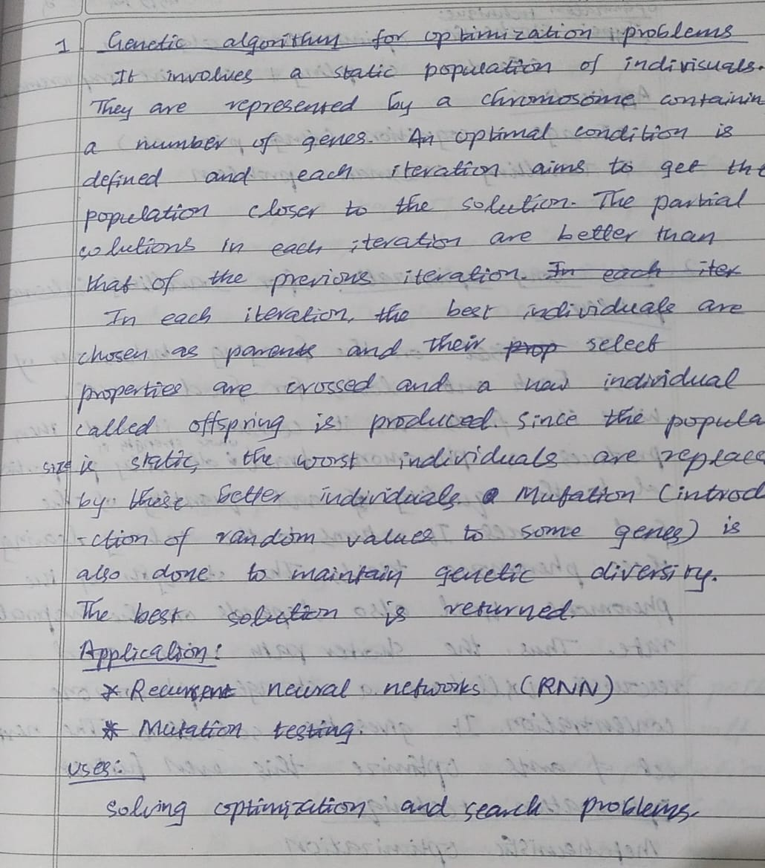

**Code:**

import random

import numpy as np

# Fitness function

def fitness(chromosome):

x = int(''.join(map(str, chromosome)), 2)

return x ** 2

# Generate a random chromosome

def generate_chromosome(length):

return [random.randint(0, 1) for _ in range(length)]

# Generate an initial population

def generate_population(size, chromosome_length):

return [generate_chromosome(chromosome_length) for _ in range(size)]

# Select two parents based on their fitness

def select_pair(population, fitnesses):

total_fitness = sum(fitnesses)

selection_probs = [f / total_fitness for f in fitnesses]

parent1 = population[random.choices(range(len(population)), weights=selection_probs)[0]]

parent2 = population[random.choices(range(len(population)), weights=selection_probs)[0]]

return parent1, parent2

# Crossover between two parents

def crossover(parent1, parent2):

point = random.randint(1, len(parent1) - 1)

offspring1 = parent1[:point] + parent2[point:]

offspring2 = parent2[:point] + parent1[point:]

return offspring1, offspring2

# Mutate a chromosome

def mutate(chromosome, mutation_rate):

return [gene if random.random() > mutation_rate else 1 - gene for gene in chromosome]

# Parameters

population_size = 10

chromosome_length = 5

mutation_rate = 0.01

generations = 20

# Initialize population

population = generate_population(population_size, chromosome_length)

for generation in range(generations):

# Calculate fitness for each chromosome

fitnesses = [fitness(chromosome) for chromosome in population]

print(f"Generation {generation + 1} best fitness: {max(fitnesses)}")

# Create a new generation

new_population = []

for _ in range(population_size // 2):

parent1, parent2 = select_pair(population, fitnesses)

offspring1, offspring2 = crossover(parent1, parent2)

offspring1 = mutate(offspring1, mutation_rate)

offspring2 = mutate(offspring2, mutation_rate)

new_population.extend([offspring1, offspring2])

# Replace the old population

population = new_population

**Output:**

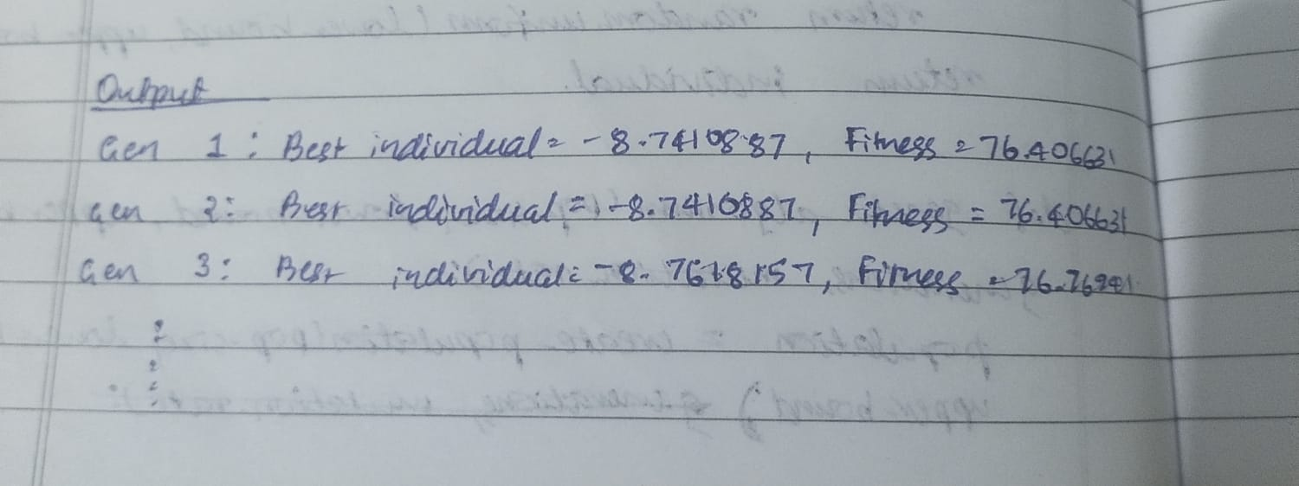

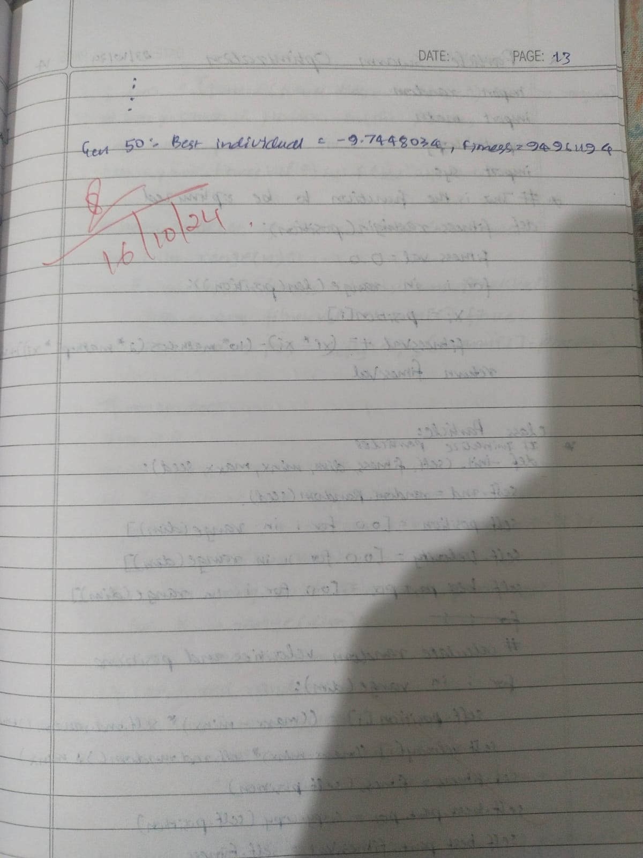

**Program 2**

**Particle Swarm Optimization**

**Algorithm:**

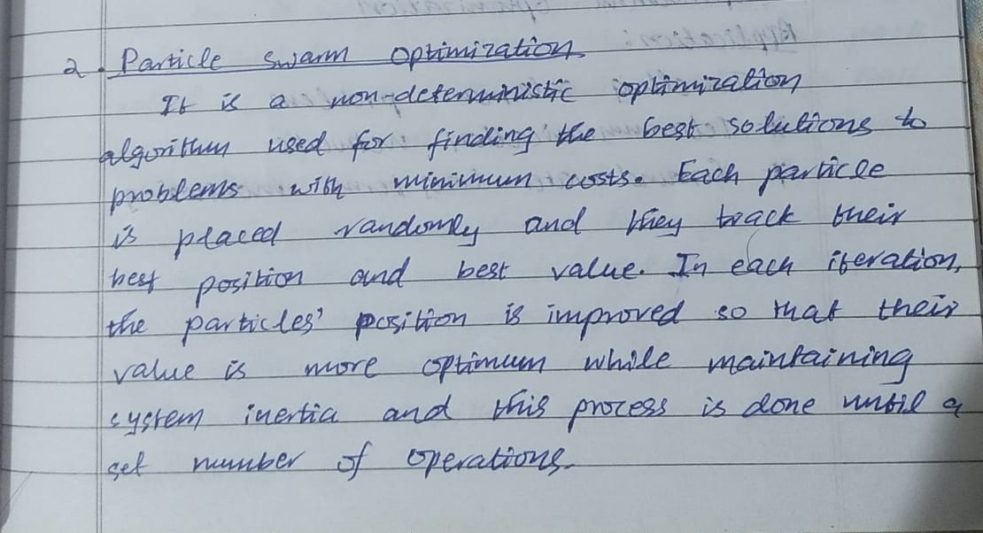

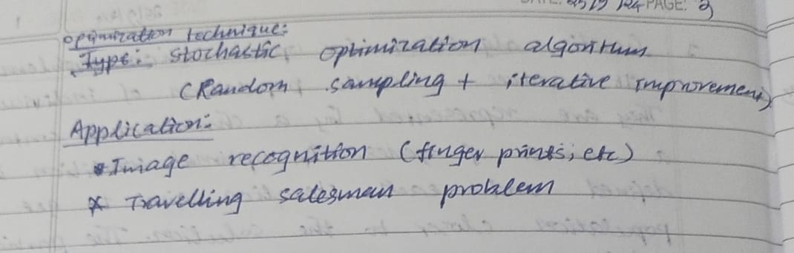

**Code:**

from __future__ import division

import random

import math

#--- COST FUNCTION ------------------------------------------------------------+

# function we are attempting to optimize (minimize)

def func1(x):

total = 0

for i in range(len(x)):

total += x[i]**2

return total

#--- PARTICLE CLASS -----------------------------------------------------------+

class Particle:

def __init__(self, x0, bounds):

self.position_i = [] # particle position

self.velocity_i = [] # particle velocity

self.pos_best_i = [] # best position individual

self.err_best_i = float('inf') # best error individual

self.err_i = float('inf') # error individual

for i in range(len(x0)):

self.velocity_i.append(random.uniform(-1, 1))

self.position_i.append(random.uniform(bounds[i][0], bounds[i][1]))

# evaluate current fitness

def evaluate(self, costFunc):

self.err_i = costFunc(self.position_i)

# check to see if the current position is an individual best

if self.err_i < self.err_best_i:

self.pos_best_i = self.position_i[:]

self.err_best_i = self.err_i

# update new particle velocity

def update_velocity(self, pos_best_g, w=0.5, c1=1.5, c2=2.0):

for i in range(len(self.position_i)):

r1 = random.random()

r2 = random.random()

vel_cognitive = c1 * r1 * (self.pos_best_i[i] - self.position_i[i])

vel_social = c2 * r2 * (pos_best_g[i] - self.position_i[i])

self.velocity_i[i] = w * self.velocity_i[i] + vel_cognitive + vel_social

# update the particle position based off new velocity updates

def update_position(self, bounds):

for i in range(len(self.position_i)):

self.position_i[i] += self.velocity_i[i]

# adjust maximum position if necessary

if self.position_i[i] > bounds[i][1]:

self.position_i[i] = bounds[i][1]

# adjust minimum position if necessary

if self.position_i[i] < bounds[i][0]:

self.position_i[i] = bounds[i][0]

#--- PSO CLASS ----------------------------------------------------------------+

class PSO:

def __init__(self, costFunc, x0, bounds, num_particles, maxiter):

self.num_dimensions = len(x0)

self.err_best_g = float('inf') # best error for group

self.pos_best_g = [] # best position for group

self.swarm = [Particle(x0, bounds) for _ in range(num_particles)]

self.costFunc = costFunc

self.bounds = bounds

self.num_particles = num_particles

self.maxiter = maxiter

def optimize(self):

for i in range(self.maxiter):

for particle in self.swarm:

particle.evaluate(self.costFunc)

# determine if current particle is the best (globally)

if particle.err_i < self.err_best_g:

self.pos_best_g = particle.position_i[:]

self.err_best_g = particle.err_i

for particle in self.swarm:

particle.update_velocity(self.pos_best_g)

particle.update_position(self.bounds)

# Print iteration details

print(f"Iteration {i+1}/{self.maxiter}, Best Fitness: {self.err_best_g}")

# Print final results

print('FINAL RESULTS:')

print(f"Best Position: {self.pos_best_g}")

print(f"Best Fitness: {self.err_best_g}")

#--- RUN ----------------------------------------------------------------------+

if __name__ == "__main__":

initial = [5, 5] # initial starting location [x1, x2, ...]

bounds = [(-10, 10), (-10, 10)] # input bounds [(x1_min, x1_max), (x2_min, x2_max), ...]

num_particles = 15

maxiter = 30

print("Starting Particle Swarm Optimization...")

optimizer = PSO(func1, initial, bounds, num_particles, maxiter)

optimizer.optimize()

**Output:**

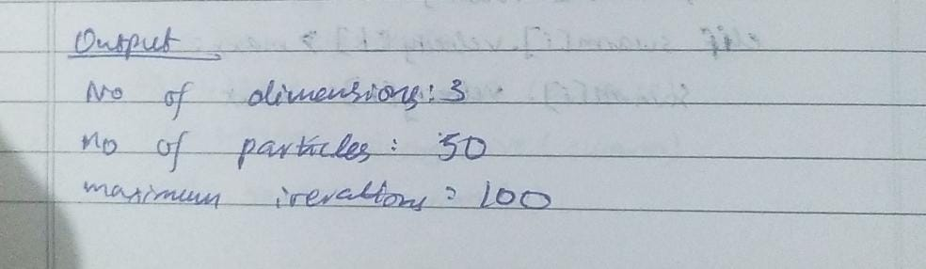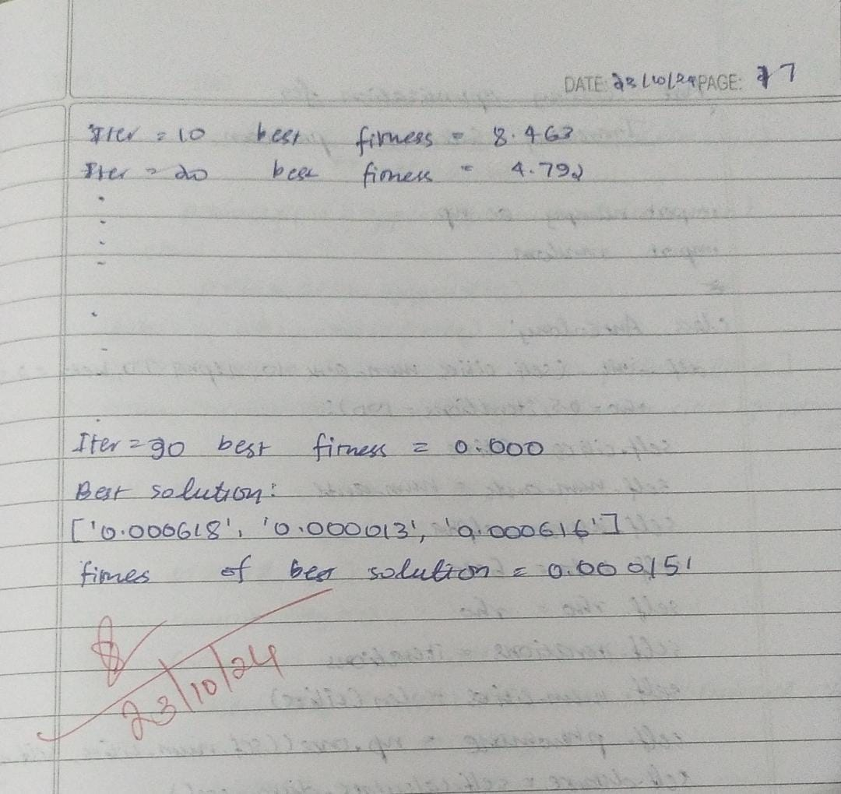

**Program 3**

**Ant Colony Optimization**

**Algorithm:**

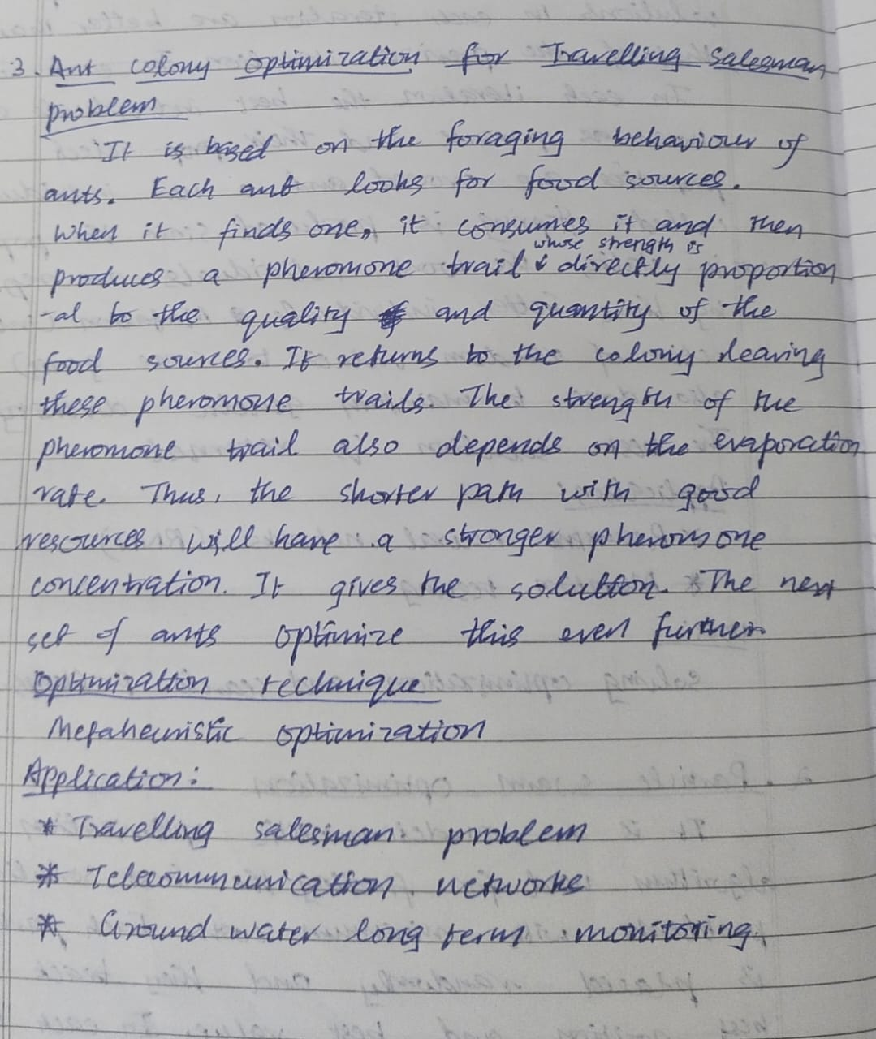

**Code:**

# Ant Colony Optimization

import numpy as np

from numpy.random import choice as np_choice

class AntColony(object):

def __init__(self, distances, n_ants, n_best, n_iterations, decay, alpha=1, beta=1):

"""

Args:

distances (2D numpy.array): Square matrix of distances. Diagonal is assumed to be np.inf.

n_ants (int): Number of ants running per iteration

n_best (int): Number of best ants who deposit pheromone

n_iterations (int): Number of iterations

decay (float): Rate it which pheromone decays. The pheromone value is multiplied by decay, so 0.95 will lead to decay, 0.5 to much faster decay.

alpha (int or float): Exponent on pheromone, higher alpha gives pheromone more weight. Default=1

beta (int or float): Exponent on distance, higher beta give distance more weight. Default=1

"""

self.distances = distances

self.pheromone = np.ones(self.distances.shape) / len(distances)

self.all_inds = range(len(distances))

self.n_ants = n_ants

self.n_best = n_best

self.n_iterations = n_iterations

self.decay = decay

self.alpha = alpha

self.beta = beta

def run(self):

shortest_path = None

all_time_shortest_path = ("placeholder", np.inf)

for i in range(self.n_iterations):

all_paths = self.gen_all_paths()

self.spread_pheromone(all_paths, self.n_best, shortest_path=shortest_path)

shortest_path = min(all_paths, key=lambda x: x[1])

print(f"Iteration {i + 1}, shortest path: {shortest_path}")

if shortest_path[1] < all_time_shortest_path[1]:

all_time_shortest_path = shortest_path

self.pheromone = self.pheromone * self.decay

return all_time_shortest_path

def spread_pheromone(self, all_paths, n_best, shortest_path):

sorted_paths = sorted(all_paths, key=lambda x: x[1])

for path, dist in sorted_paths[:n_best]:

for move in path:

self.pheromone[move] += 1.0 / self.distances[move]

def gen_path_dist(self, path):

total_dist = 0

for ele in path:

total_dist += self.distances[ele]

return total_dist

def gen_all_paths(self):

all_paths = []

for i in range(self.n_ants):

path = self.gen_path(0)

all_paths.append((path, self.gen_path_dist(path)))

return all_paths

def gen_path(self, start):

path = []

visited = set()

visited.add(start)

prev = start

for i in range(len(self.distances) - 1):

move = self.pick_move(self.pheromone[prev], self.distances[prev], visited)

path.append((prev, move))

prev = move

visited.add(move)

path.append((prev, start)) # going back to where we started

return path

def pick_move(self, pheromone, dist, visited):

pheromone = np.copy(pheromone)

pheromone[list(visited)] = 0

row = pheromone ** self.alpha * ((1.0 / dist) ** self.beta)

norm_row = row / row.sum()

move = np_choice(self.all_inds, 1, p=norm_row)[0]

return move

# Example usage

if __name__ == "__main__":

distances = np.array([[np.inf, 2, 2, 5, 7],

[2, np.inf, 4, 8, 2],

[2, 4, np.inf, 1, 3],

[5, 8, 1, np.inf, 2],

[7, 2, 3, 2, np.inf]])

ant_colony = AntColony(distances, n_ants=5, n_best=1, n_iterations=10, decay=0.95, alpha=1, beta=1)

shortest_path = ant_colony.run()

print("Final shortest path:", shortest_path)

**Output:**

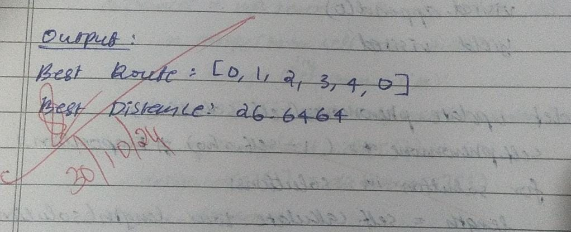

**Program 4**

**Cuckoo Search Algorithm**

**Algorithm:**

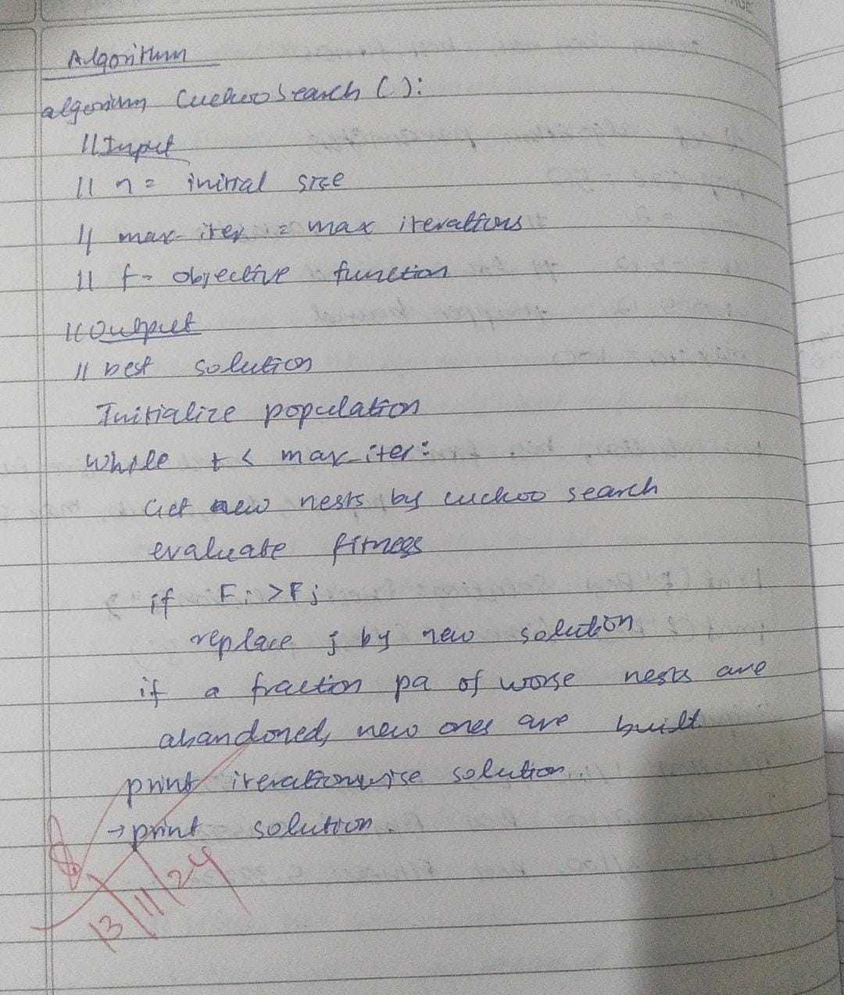

**Code:**

# Cuckoo Search Algorithm

import random

import networkx as nx

import numpy as np

import math

import datetime

import pandas as pd

class Cuckoo:

def __init__(self, path, G, eps = 0.9):

self.path = path

self.G = G

self.nodes = list(G.nodes)

self.eps = eps

self.fitness = self.calculate_fitness()

"""

Function to Compute fitness value.

"""

def calculate_fitness(self):

fitness = 0.0

for i in range(1, len(self.path)):

total_distance = 0

curr_node = self.path[i-1]

next_node = self.path[i]

if self.G.has_edge(curr_node, next_node):

fitness += self.G[curr_node][next_node]['weight']

else:

fitness += 0

fitness = np.power(abs(fitness + self.eps), 2)

return fitness

def generate_new_path(self):

"""

This function generates a random solution (a random path) in the graph

"""

nodes = list(self.G.nodes)

start = nodes[0]

end = nodes[-1]

samples = list(nx.all_simple_paths(self.G, start, end))

for i in range(len(samples)):

if len(samples[i]) != len(nodes):

extra_nodes = [node for node in nodes if node not in samples[i]]

random.shuffle(extra_nodes)

samples[i] = samples[i] + extra_nodes

sample_node = random.choice(samples)

return sample_node

class CuckooSearch:

def __init__(self, G, num_cuckoos, max_iterations, beta):

self.G = G

self.nodes = list(G.nodes)

self.num_cuckoos = num_cuckoos

self.max_iterations = max_iterations

self.beta = beta

self.cuckoos = [Cuckoo(random.sample(self.nodes, len(self.nodes)), self.G) for _ in range(self.num_cuckoos)]

self.test_results = []

self.test_cases = 0

"""

Function to buld new nests at new location and abandon old ones using Levi flights.

"""

def levy_flight(self):

sigma = (math.gamma(1 + self.beta) * np.sin(np.pi * self.beta / 2) / (math.gamma((1 + self.beta) / 2) * self.beta * 2 ** ((self.beta - 1) / 2))) ** (1 / self.beta)

u = np.random.normal(0, sigma, 1)

v = np.random.normal(0, 1, 1)

step = u / (abs(v) ** (1 / self.beta))

return step

def optimize(self):

for i in range(self.max_iterations):

for j in range(self.num_cuckoos):

cuckoo = self.cuckoos[j]

step = self.levy_flight()

new_path = cuckoo.generate_new_path()

new_cuckoo = Cuckoo(new_path, self.G)

if new_cuckoo.fitness > cuckoo.fitness:

self.cuckoos[j] = new_cuckoo

self.test_cases+=1

self.cuckoos = sorted(self.cuckoos, key=lambda x: x.fitness, reverse=True)

best_path=self.cuckoos[0].path

best_fitness=self.cuckoos[0].fitness

self.test_results.append([i, best_fitness, self.test_cases])

last_node = list(self.G.nodes)[-1]

last_node_index = best_path.index(last_node) + 1

return best_path[:last_node_index], best_fitness

if __name__ == "__main__":

"""

Example usage

"""

Gn = nx.DiGraph()

#Add nodes to the graph

for i in range(11):

Gn.add_node(i)

edges = [(0, 1,{'weight': 1}), (1, 3,{'weight': 2}), (1, 2,{'weight': 1}),(2, 4,{'weight': 2}),

(3, 2,{'weight': 2}),(3, 4,{'weight': 1}),(3, 5,{'weight': 2}),(3, 7,{'weight': 4}),

(4, 5,{'weight': 1}),(4, 6,{'weight': 2}),(5, 7,{'weight': 2}),(5, 8,{'weight': 3}),

(6, 7,{'weight': 1}),(7, 9,{'weight': 2}),(8, 10,{'weight': 2}),(9, 10,{'weight': 1})]

Gn.add_edges_from(edges)

csa = CuckooSearch(Gn, num_cuckoos = 30, max_iterations=1000, beta=0.27)

start = datetime.datetime.now()

best_path, best_fitness = csa.optimize()

end = datetime.datetime.now()

csa_time = end - start

csa_test_data = pd.DataFrame(csa.test_results,columns = ["iterations","fitness_value","test_cases"])

print("Optimal path: ", best_path)

print("Optimal path cost: ", best_fitness)

**Output:**

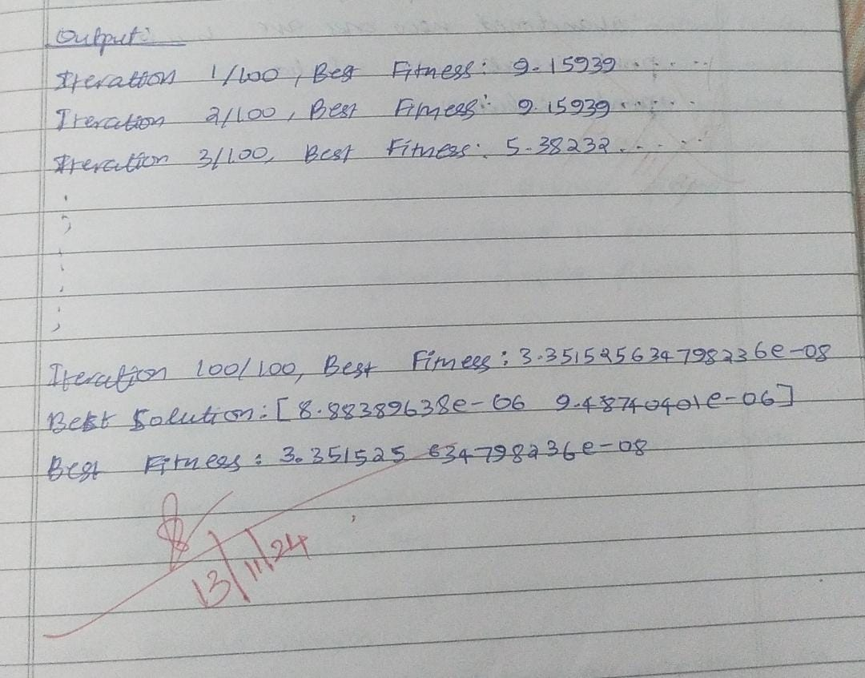

**Program 5**

**Gray Wolf Optimizer**

**Algorithm:**

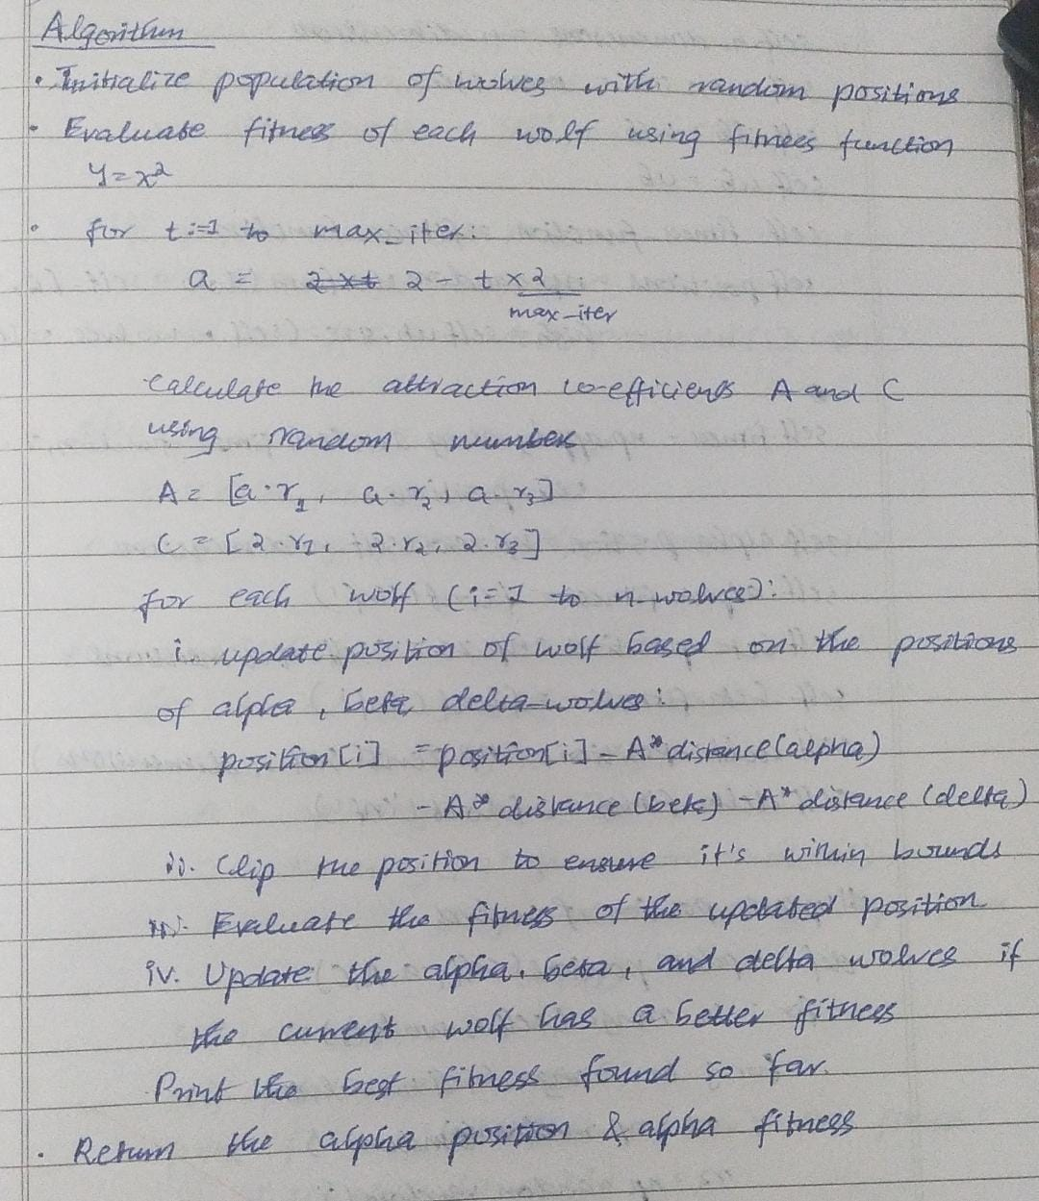

**Code:**

import random

import math

import copy

# Fitness functions

def fitness_rastrigin(position):

return sum(x**2 - 10 * math.cos(2 * math.pi * x) + 10 for x in position)

def fitness_sphere(position):

return sum(x**2 for x in position)

# Wolf class

class Wolf:

def __init__(self, fitness, dim, minx, maxx, seed):

self.rnd = random.Random(seed)

self.position = [self.rnd.uniform(minx, maxx) for _ in range(dim)]

self.fitness = fitness(self.position)

def gwo(fitness, max_iter, n, dim, minx, maxx):

rnd = random.Random(0)

population = [Wolf(fitness, dim, minx, maxx, i) for i in range(n)]

population.sort(key=lambda w: w.fitness)

alpha_wolf, beta_wolf, gamma_wolf = copy.deepcopy(population[:3])

for Iter in range(max_iter):

if Iter % 10 == 0 and Iter > 0:

print(f"Iter = {Iter} best fitness = {alpha_wolf.fitness:.3f}")

a = 2 * (1 - Iter / max_iter)

for wolf in population:

A1, A2, A3 = [a * (2 * rnd.random() - 1) for _ in range(3)]

C1, C2, C3 = [2 * rnd.random() for _ in range(3)]

X1 = [alpha_wolf.position[j] - A1 * abs(C1 * alpha_wolf.position[j] - wolf.position[j]) for j in range(dim)]

X2 = [beta_wolf.position[j] - A2 * abs(C2 * beta_wolf.position[j] - wolf.position[j]) for j in range(dim)]

X3 = [gamma_wolf.position[j] - A3 * abs(C3 * gamma_wolf.position[j] - wolf.position[j]) for j in range(dim)]

Xnew = [(X1[j] + X2[j] + X3[j]) / 3.0 for j in range(dim)]

fnew = fitness(Xnew)

if fnew < wolf.fitness:

wolf.position = Xnew

wolf.fitness = fnew

population.sort(key=lambda w: w.fitness)

alpha_wolf, beta_wolf, gamma_wolf = copy.deepcopy(population[:3])

return alpha_wolf.position

# Driver code

def run_gwo(fitness, func_name, dim=3, num_particles=50, max_iter=100, minx=-10.0, maxx=10.0):

print(f"\nBegin grey wolf optimization on {func_name} function\n")

print(f"Goal is to minimize {func_name} in {dim} variables")

print(f"Function has known min = 0.0 at ({', '.join(['0'] * dim)})")

print(f"Setting num_particles = {num_particles}")

print(f"Setting max_iter = {max_iter}\n")

best_position = gwo(fitness, max_iter, num_particles, dim, minx, maxx)

print(f"\nGWO completed\n")

print(f"Best solution found: {[f'{x:.6f}' for x in best_position]}")

print(f"Fitness of best solution = {fitness(best_position):.6f}\n")

# Run GWO for Rastrigin and Sphere functions

run_gwo(fitness_rastrigin, "Rastrigin")

**Output**:

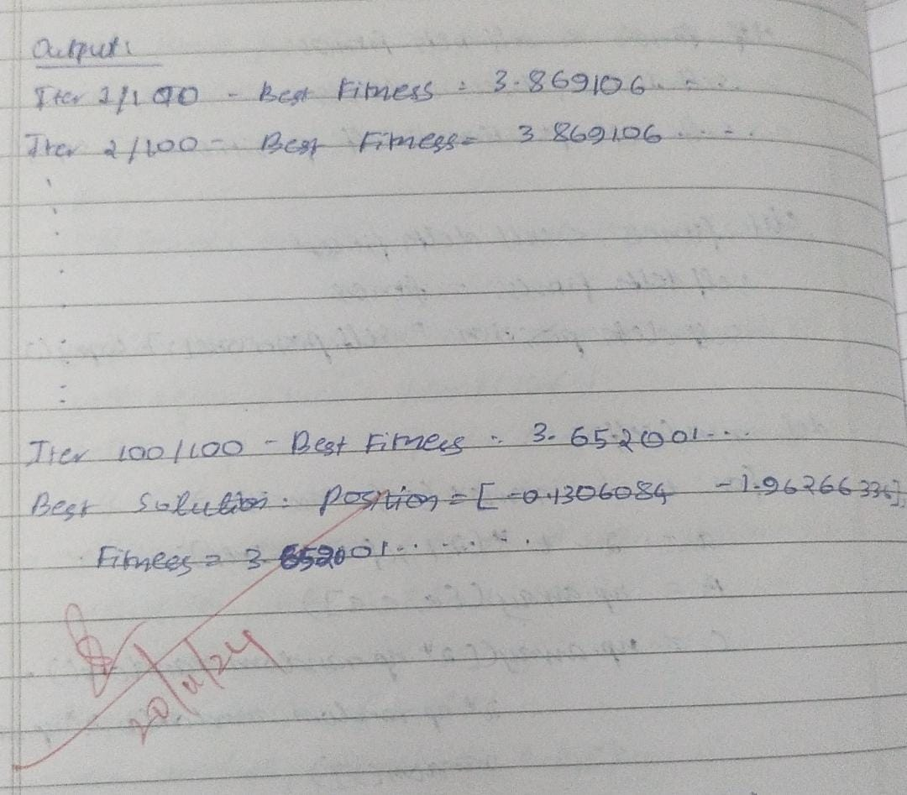

**Program 6**

**Parallel Cell Algorithm**

**Algorithm:**

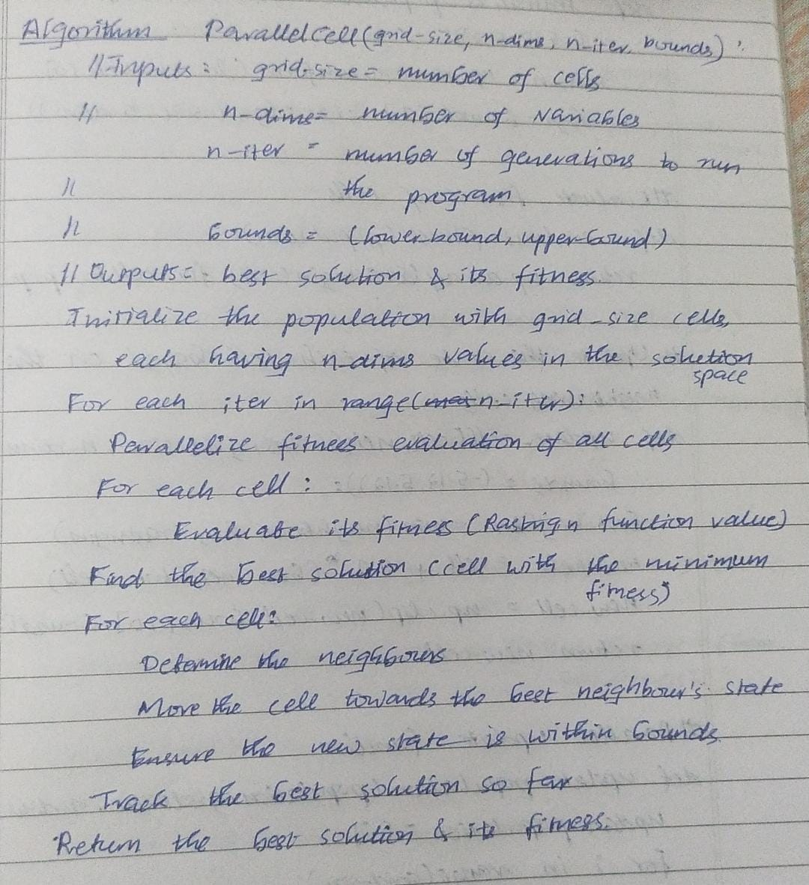

**Code:**

#Parallel Cell Algorithm

import numpy as np

from concurrent.futures import ThreadPoolExecutor

# Define the grid size

grid_size = 5 # Set a smaller grid for easier display, e.g., 10x10

grid = np.random.randint(0, 2, (grid_size, grid_size))

# Define a simple rule (e.g., Conway's Game of Life)

def game_of_life_cell(i, j, grid):

# Count live neighbors

neighbors = grid[i-1:i+2, j-1:j+2]

total = np.sum(neighbors) - grid[i, j]

if grid[i, j] == 1:

return 1 if total in [2, 3] else 0

else:

return 1 if total == 3 else 0

def update_cell(i, j, grid):

return game_of_life_cell(i, j, grid)

def parallel_update(grid):

# Create a copy of the grid to store updated values

new_grid = grid.copy()

with ThreadPoolExecutor() as executor:

futures = []

for i in range(1, grid.shape[0]-1):

for j in range(1, grid.shape[1]-1):

futures.append(executor.submit(update_cell, i, j, grid))

# Collect results from the futures and update the new grid

idx = 0

for future in futures:

i, j = divmod(idx, grid.shape[1] - 2)

new_grid[i+1, j+1] = future.result()

idx += 1

return new_grid

# Update the grid

grid = parallel_update(grid)

# Display the grid as a matrix (instead of plotting)

print("Updated Grid after applying Conway's Game of Life rule:")

print(grid)

**Output:**

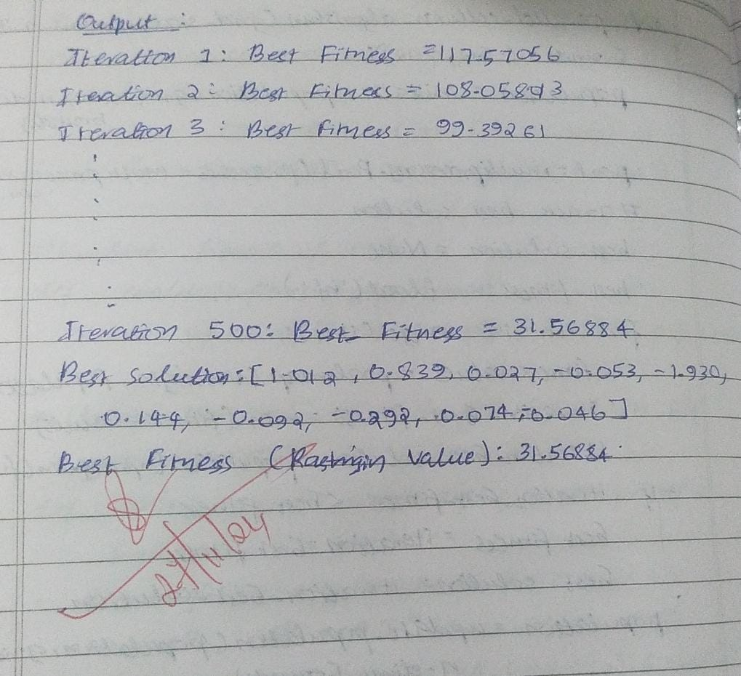

**Program 7**

**Gene Expression Algorithm**

**Algorithm:**

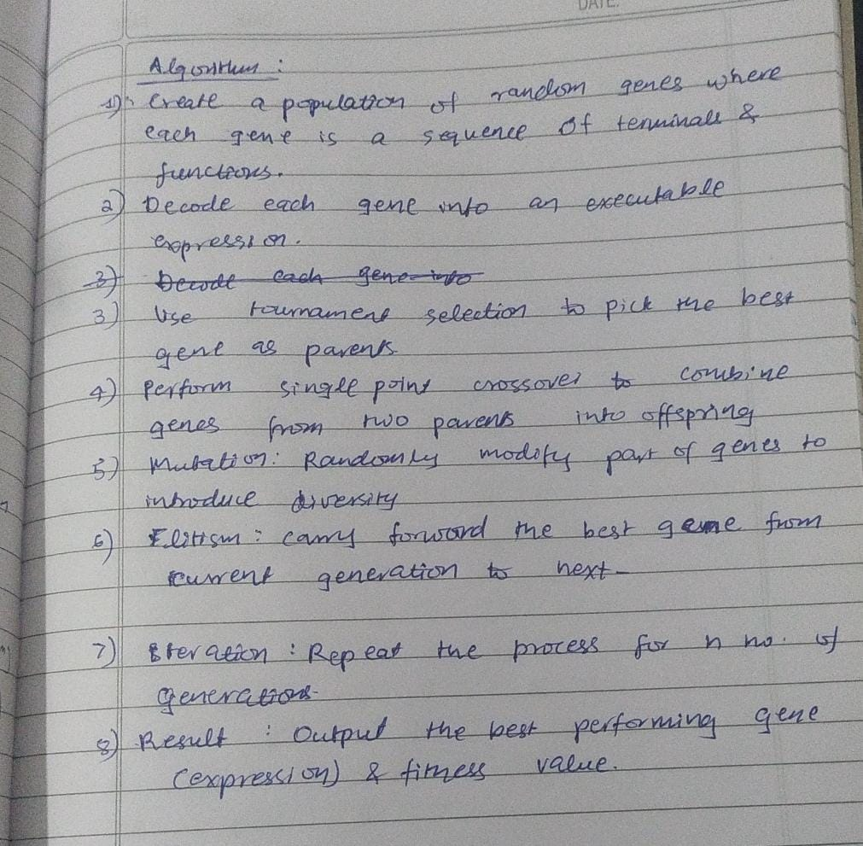

**Code:**

# Optimization via gene expression

import random

# Fitness function: minimize f(x) = x^2

def fitness(x):

return -x**2 # Negative because higher fitness is better

# Generate initial population

def generate_population(size, lower, upper):

return [random.uniform(lower, upper) for _ in range(size)]

# Crossover

def crossover(parent1, parent2):

alpha = random.random()

return alpha * parent1 + (1 - alpha) * parent2

# Mutation

def mutate(gene, mutation_rate, lower, upper):

if random.random() < mutation_rate:

return random.uniform(lower, upper)

return gene

# Main Genetic Algorithm

def genetic_algorithm(pop_size, generations, mutation_rate, lower, upper):

population = generate_population(pop_size, lower, upper)

for _ in range(generations):

# Evaluate fitness

population.sort(key=fitness, reverse=True)

new_population = []

# Selection and reproduction

for i in range(pop_size // 2):

parent1, parent2 = random.choices(population[:pop_size // 2], k=2)

child = mutate(crossover(parent1, parent2), mutation_rate, lower, upper)

new_population.extend([parent1, child])

population = new_population

# Best solution

best_gene = max(population, key=fitness)

return best_gene, -fitness(best_gene)

# Run the algorithm

best_solution, best_fitness = genetic_algorithm(50, 100, 0.1, -10, 10)

print(f"Best Solution: {best_solution}, Fitness: {best_fitness}")

**Output:**

